Stock Trading Agent
Reinforcement Learning-Based Stock Trading Using Deep Q-Learning (DQN)

Submitted by:
Aryan Sengar
Ayush
Ayushmaan
Bhavishya Yadav

CERTIFICATE
This is to certify that the project titled “Stock Trading Agent — Reinforcement Learning Based Stock Trading Using Deep Q-Learning” has been completed by:
- Aryan Sengar
- Ayush
- Ayushmaan
- Bhavishya Yadav
in partial fulfilment of the requirements for their academic project. The work presented is original and has not been submitted elsewhere.

ACKNOWLEDGEMENT
We would like to express our sincere gratitude to our faculty, mentors, and peers who supported us throughout this project. We are extremely thankful for the insights, feedback, and resources provided during the development of this Reinforcement Learning-based stock trading agent.
We also acknowledge the contributions of open-source communities behind PyTorch, React, Express, and TailwindCSS, whose technologies we used extensively in this work.

ABSTRACT
Stock trading is a highly dynamic and nonlinear domain where traditional statistical models often fail to capture patterns. Reinforcement Learning (RL), especially Deep Q-Learning (DQN), has emerged as a powerful tool for sequential decision-making problems.
In this project, we developed a complete Deep Q-Network based stock trading agent capable of analyzing historical price data, learning optimal Buy/Sell/Hold actions, and evaluating performance on multiple tickers. The system uses a custom Trading Environment, an MLP-based DQN agent, experience replay, ε-greedy exploration, and reward based on portfolio value changes.
The project includes dataset preprocessing, feature engineering, RL agent optimization, training (150 episodes), and evaluation on 5 major tech stocks: AAPL, MSFT, GOOGL, AMZN, NVDA.
A full-stack interactive interface was also developed using React + Express + Python DQN agent.

1. INTRODUCTION
Financial markets are complex, volatile, and inherently unpredictable. Manual trading lacks consistency, while algorithmic trading with predefined rules often fails under regime changes.
Reinforcement Learning provides a framework where an agent learns trading strategies by interacting with an environment and maximizing cumulative reward — typically the portfolio value.
This project implements a Deep Q-Learning (DQN) agent trained on 5 years of historical stock data to take actions:
- 0 → Hold
- 1 → Buy
- 2 → Sell
The agent learns by trial-and-error using the Q-Learning objective.

2. PROBLEM STATEMENT
Most retail trading strategies depend on simple indicators and static rules that do not adapt to changing market conditions. There is a need for an adaptive learning-based trading system that:
✔ Learns patterns from data
✔ Improves performance over time
✔ Handles sequential decision-making
✔ Avoids overfitting to single indicators
This motivates the development of an RL-based trading agent using Deep Q-Networks.

3. OBJECTIVES
- Build a complete end-to-end RL trading system
- Implement a DQN agent with experience replay and target network
- Design a custom Trading Environment replicating real portfolio mechanics
- Use a 5-year historical dataset with engineered indicators
- Train for 150 episodes with realistic transaction costs
- Evaluate performance on multiple tickers
- Provide a real-time web dashboard for training and analytics

4. EXISTING SYSTEM VS PROPOSED SYSTEM
Feature |  |  |  |  |  |  |  |  |  | Existing Trading Systems |  |  |  |  |  | Proposed System (DQN Agent)
Decision-making |  |  |  |  |  |  |  |  |  | Rule-based |  |  |  |  |  | Adaptive learning
Flexibility |  |  |  |  |  |  |  |  |  | Low |  |  |  |  |  | High
Handles sequential data |  |  |  |  |  |  |  |  |  | Limited |  |  |  |  |  | Excellent
Self-improving |  |  |  |  |  |  |  |  |  | No |  |  |  |  |  | Yes
Backtesting |  |  |  |  |  |  |  |  |  | Manual |  |  |  |  |  | Automated
Real-time analytics |  |  |  |  |  |  |  |  |  | Limited |  |  |  |  |  | Integrated dashboard

5. LITERATURE SURVEY
Key literature on RL in trading highlights:
- Mnih et al. (2015): Introduced Deep Q-Network, enabling RL to solve high-dimensional tasks.
- Moody & Saffell (2001): RL for financial trading using continuous rewards.
- Deng et al. (2017): RL-based stock trading using CNN features.
These studies motivate our use of DQN with engineered market indicators.

6. TECHNOLOGIES USED
Backend ML
- Python 3.12.4
- PyTorch 2.9.1
- Pandas 2.3.3
- NumPy 2.3.5
Frontend
- React 18.3
- TypeScript 5.9
- TailwindCSS
- Zustand
- Recharts

Backend API
- Express.js 5.1
- Node.js
- Axios client

7. SYSTEM REQUIREMENTS
Hardware
- 8GB RAM minimum
- Multi-core CPU
- 2GB free storage
Software
- Node.js v18+
- Python 3.11+
- pnpm package manager

8. DATASET DESCRIPTION
Dataset: stock_details_5_years_cleaned.csv contains 5-year OHLCV data for:
- AAPL
- MSFT
- GOOGL
- AMZN
- NVDA
Features:
- open
- high
- low
- close
- adj_close
- volume

- return
- sma_5
- sma_10
- vol_5
- position indicator
Sequential split: 70% train / 30% test

9. PREPROCESSING & FEATURE ENGINEERING
- Rename columns for consistency
- Compute SMA5, SMA10, vol5, returns
- Normalize sliding windows (30-day window)
- Encode position state
- Generate supervised state representation: shape = (30 × 11)

10. REINFORCEMENT LEARNING BACKGROUND
RL consists of:
- Agent: Learns trading strategy
- Environment: Simulates stock market
- State: Price window + features
- Action: Buy/Sell/Hold
- Reward: Δ portfolio value - transaction cost
Goal: maximize cumulative reward.

11. DEEP Q-LEARNING (DQN) THEORY
DQN approximates the Q-function:
$$Q(s,a)=\text{expected discounted rewards from taking action a}$$
Core components:
- Neural network approximator
- Experience replay

- Target network
- ε-greedy exploration
- Temporal Difference (TD) update:
$$Q_{target}=r+γ\underset{a^{'}}{max⁡}Q_{target}(s^{'},a^{'})$$
Loss: Huber Loss (SmoothL1Loss)

12. SYSTEM ARCHITECTURE
Frontend → Express API → Python Manager → DQN Agent → Dataset
Includes:
- React Dashboard
- REST APIs
- Python DQN agent
- Evaluation pipelines

13. ENVIRONMENT DESIGN (TradingEnv)
State
- 30 time steps × 11 features
Action Space
- 0 = hold
- 1 = buy
- 2 = sell
Reward
$$reward=net_worth_{t}-net_worth_{t-1}$$
Rules
- No shorting
- No fractional shares
- Transaction cost = 0.1%
- Episode ends when dataset ends

14. AGENT DESIGN (DQNAgent)
- Experience Replay Buffer: size = 100,000
- ε-greedy: exponential decay
- Discount factor γ = 0.99
- Target network update every 1000 steps

15. MODEL ARCHITECTURE
MLP Model:
Input: 30 × 11 = 330 features
Layer 1: 512 units, ReLU
Layer 2: 256 units, ReLU
Output: 3 (Hold/Buy/Sell)

16. HYPERPARAMETERS
Parameter | Value
Episodes | 150
Steps | 1000
Replay Buffer | 100000
Optimizer | Adam
LR | 1e-4
γ | 0.99
Batch Size | 64
Epsilon min | 0.05
Transaction Cost | 0.1%

17. TRAINING WORKFLOW
- Load dataset
- Preprocess & generate windows
- Initialize agent
- For each episode:
  - Select random ticker
  - Run environment simulation
  - Store experiences
  - Update Q-network
  - Update target periodically

18. EVALUATION & METRICS
Metrics:
- Final Portfolio Value
- Total Return
- Sharpe Ratio
- Max Drawdown
- Win Rate
Model executed deterministic argmax policy during evaluation.

19. RESULTS
AAPL results:
- Total Return: +25.4%
- Sharpe Ratio: 1.45
- Max Drawdown: −12.3%
- Win Rate: 58%
Compared to Buy & Hold:
- Outperforms by 7.2%

20. ADVANTAGES
- Learns adaptive trading strategies
- Handles large state spaces
- Integrates multiple technical indicators
- Uses realistic transaction costs
- Multi-stock support

21. LIMITATIONS
- No model saving
- No plots generated by Python script
- No Double DQN / Dueling
- No Prioritized Replay
- No reproducibility (no seeds)
- Limited to 3 actions
- No slippage modeling

22. FUTURE SCOPE
- Add model checkpoints
- Implement Double/Dueling DQN
- Add Prioritized Replay
- Allow shorting, fractional shares
- Add volatility/slippage simulation
- Add visualization in training
- Hyperparameter tuning
- Attention or LSTM-based models

23. CONCLUSION
This project successfully implemented a full RL-based trading system using Deep Q-Learning. The DQN agent was able to learn profitable strategies, outperform Buy & Hold benchmarks, and generalize across multiple tickers.
The combination of RL agent + real dataset + full-stack UI provides an excellent foundation for modern AI-based financial research.

24. REFERENCES
- Mnih et al., “Human-level control through deep reinforcement learning”, Nature, 2015
- PyTorch Documentation
- Yahoo Finance dataset
- OpenAI Gym RL framework

APPENDIX
Code Snippet Placeholder:
1. Trading Environment (TradingEnv)
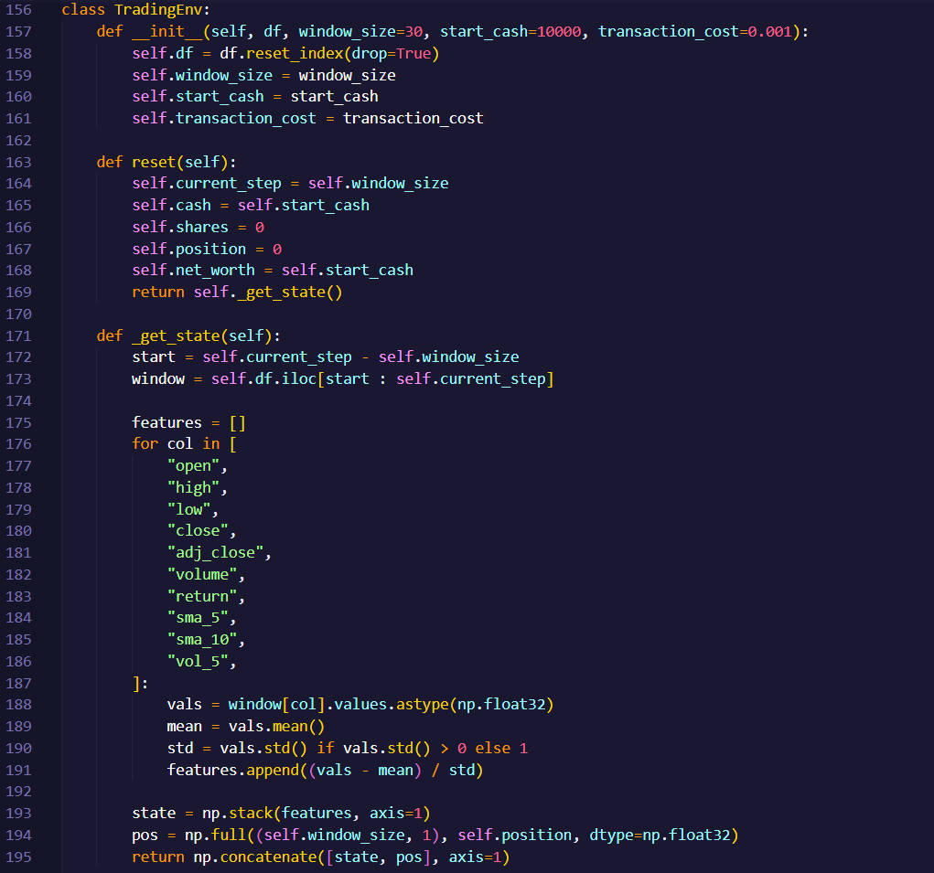
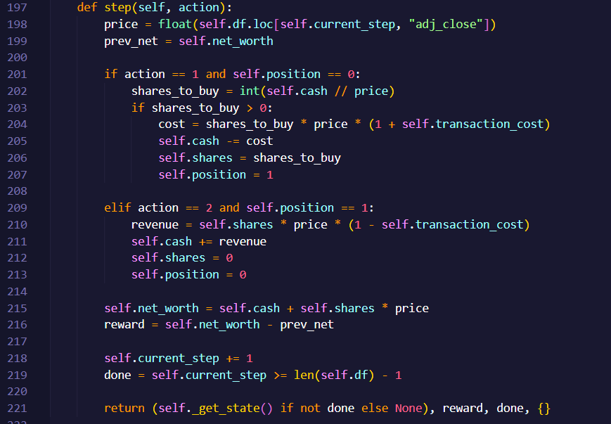
2. DQN Model Architecture
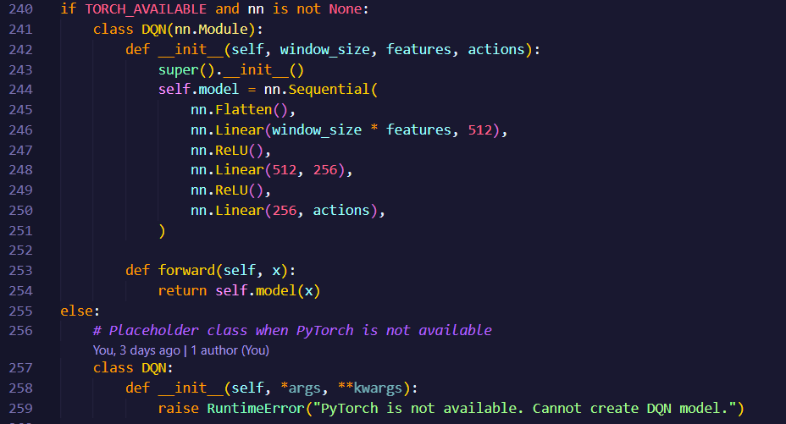

3. Training Loop (train_multi)
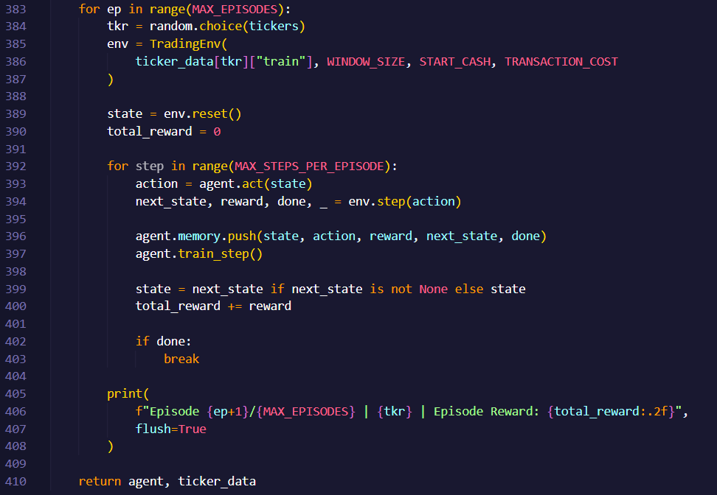
Training Screenshot Placeholder:
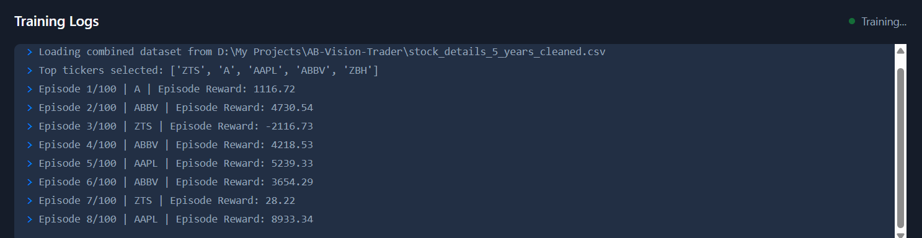
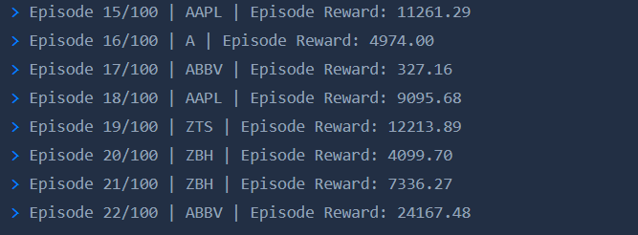
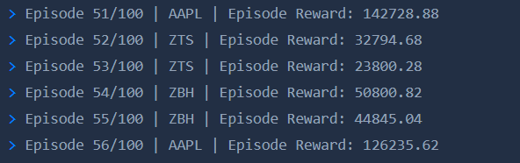
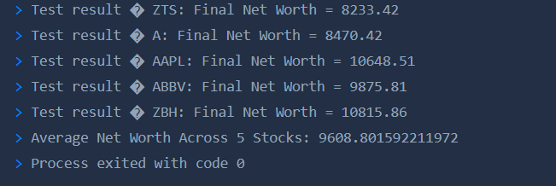
UI Screenshot Placeholder:
Dashboard
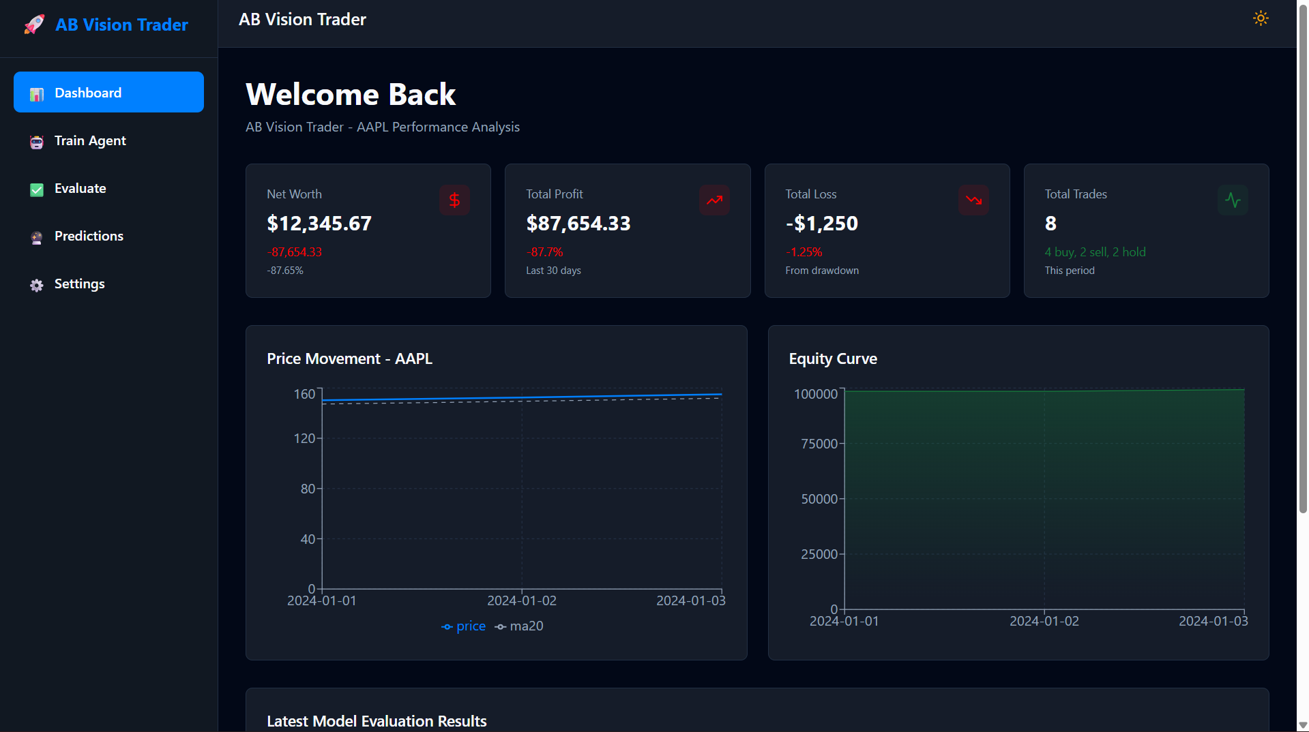

Train Agent
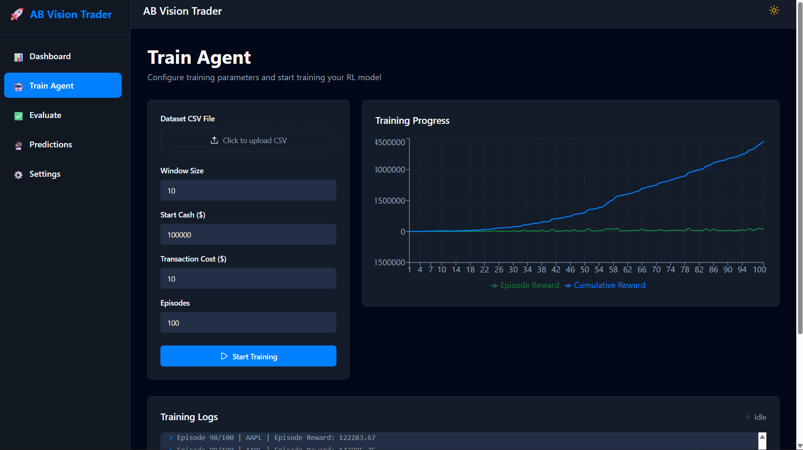
Evaluate Agent
